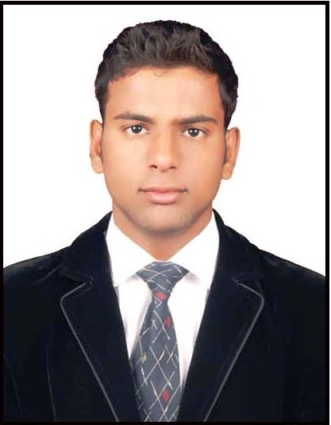

Mohammed Mohsin Yahiya
BANDLAGUDA , CHANDRAYANGUTTA
HYDERABAD.
CELL NO : +91 8919472765
Email :- mohsinuae18@gmail.com

CARRER OBJECTIVE

Professional Summary
Energetic Fashion Sales Executive who is constantly in touch with up to date information from all of the top fashion regions of the world. Adept at determining when a new style is ready to sell helping to create effective marketing campaigns and working with designers to develop the next great fashion idea. Specializes in professional and youth fashions.

To obtain a creative and challenging position in an organization.
That gives me an Opportunity for self improvement and leadership,
While contributing to the symbolic Growth of the organization with my technical,
Innovative and logical skills.

EDUCATIONAL QUALIFICATIONS

- Diploma in Computer Hardware & Networking

- Intermediate from Board of Intermediate (C.S.E)

- S.S.C from Board of Secondary Education

STRENGHTS

Hard working creative, dedicated, well organized, self motivated and positive attitude.
- Ability to work in multi  cultural environment.
- Self-motivated and pleasing manners.
WORK EXPERIENCE

AL MAHA BUSINESS CENTRE. (DUBAI U.A.E)

Position : Technical Supervisor

Duration : JAN- 2019 TO JUL- 2019

RAMEE GRAND HOTEL AND SPA. (BAHRAIN)

Position : Cashier

Duration : OCT - 2016 TO JUL- 2017

KOPAL COMPUTERS & PERIPHERALS. (SECUNDERABAD)

Position : Desktop Support Engineer

Duration : 2014 To 2016

NAME : MD. WASEEM AKRAM
PROFESSIONAL TRAININGS

- Microsoft Certified Systems Engineer (MCSE)

- Microsoft Certified IT Professional (MCITP)

- Computer Hardware Engineering (COMITIA A+)

- Diploma in computer applications (DCA)
PERSONAL PROFILE

Name : MOHAMMED MOHSIN YAHIYA
Father Name : MOHAMMED YAHIYA
Gender : Male
Marital Status : Single
Nationality : Indian
Date of Birth : 17-Sep-1992
Languages Know : English, Arabic, Urdu & Hindi
Hobbies : Reading Books, Chess & Cricket

Passport Details
Passport Number : K6876336
Date of Issue : 09/10/2012
Date of Expiry : 08/10/2022
DECLARATION

I hereby Declare that the furnished information is true and correct to the best of my
Knowledge and belief.

Place: Hyderabad
DATE:

(Mohammed Mohsin Yahiya)

